Database Design

彭鹏 201830570231

郭泓树 201830570088

林师言 201830570194

陈秉亮 201830570019

School of Computer Science and Engineering

SCUT

2020.9---2020.12

**With the ORM functions, we can create the database tables as a class and use migration function built-in Django. Also, add, delete, modify and search can be easier to achieve via ORM functions and process the database as a normal class of object.**

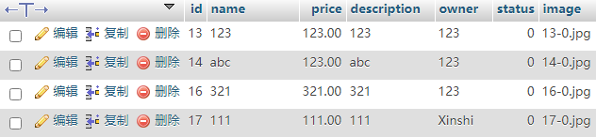

**Commodity**



**Teacher(Manager)**

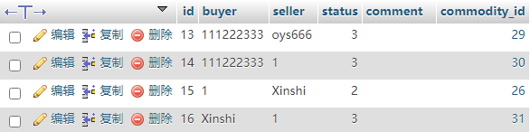

**Transaction**

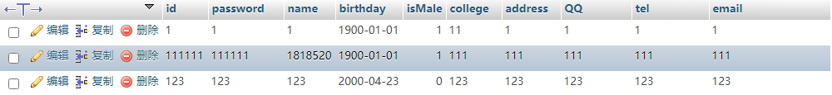

**User**

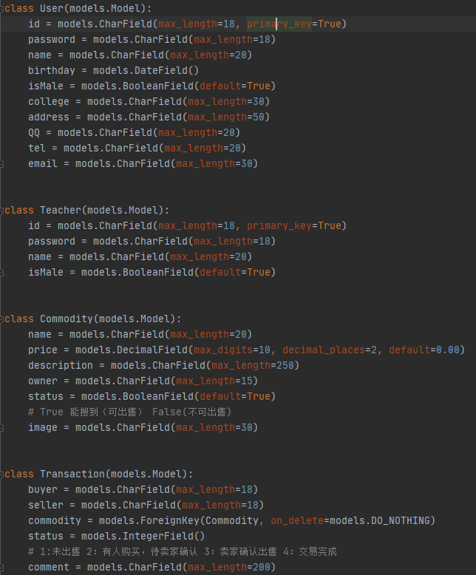

**Program of ORM**



**Add: Create a commodity from the input settings.**



**Delete: Delete one commodity**



**Modify: Use update function to modify the data.**



**Search: Search from user table where “id=input account” and “password = input password”**

E-R Diagram:

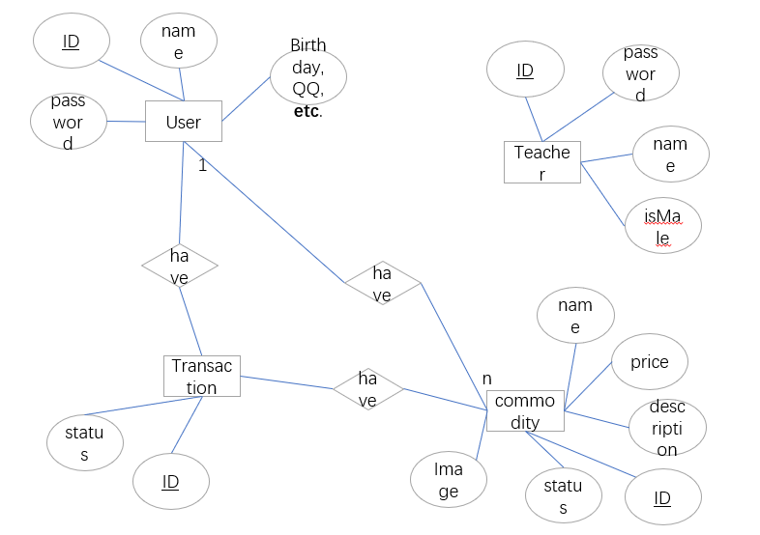

Relations and details:

In our database design, the system mainly has 4 tables, the user, teacher, transaction and commodity. The relations focus on the user, commodity and transaction. The teacher table is a record table for manager account, so that no relations with the others.

The user will be connected with transactions via “have” relation and it is a one-to-many relation. The user will also have commodities via “have” relation. This relation is also one-to-many and when the user been deleted, the corresponding commodity need to be deleted cascade. The relation between the transaction and the commodity is one-to-one relation. For each commodity, the system will create one corresponding transaction when been purchased.

All the other attributes of entities are normal attributes without special design.

For the transaction status, one integer is used to represent. 1 means not been sold; 2 means someone want to buy and waiting for seller’s confirm; 3 means the seller agree to sell and 4 means the buyer confirm the finish of transaction.

For the commodity status, we use a Boolean to represent whether can be searched. For items in the selling process or having sold, they cannot be accessed via searching.

This two status will be modified when processing the purchase.